

**American International University-**

**Bangladesh**

**INTRODUCTION TO DATABASE**

**Course Faculty: SIFAT RAHMAN AHONA**

**Section: E**

**Air Management System**

**SUBMITTED BY**

**Barua, Diganta 18-36262-1**

**TABLE OF CONTENTS**

**S.NO TITLE**

**01. INTRODUCTION**

**02. CASE STUDY**

**03. ENTITY-RELATIONSHIP DIAGRAM**

**04. NORMALIZATION**

**05. TABLE CRATION**

**06. SEQUENCE**

**06. DATA INSERTION**

**07. QUERIES**

**08. CONCLUSION**

**Introduction:**

A database management system is a system software for creating and managing databases. The DBMS provides users and programmers with a systematic way to create, retrieve, update and manage data.

In this project, an air management system is created by the concept of database management system. This project contains some entities,attributes,relationships which are based on air management. Oracle 10g is used in this project.So,the main purpose of this project is to know about the basic concept of database management system.

**Case Study:**

A well known air management company has many agency.An aency has an id,phone number, city, country. A passenger has to buy tickets from via agency.Ticket has ticket no, price, category. A passenger has a name, passenger id, passport no, mobile no, date of birth. Passenger travels by plane and plane has an id, reg no, capacity, model, arrival time, departure time, destination.Agency provides pilot to fly plane. A pilot has name, pilot id, type, salary, hire date, phone number, age. Different type of employees work in the plane to provide service to the passengers. Employee has name, id, type, phone, salary.

**ER-DIAGRAM:**

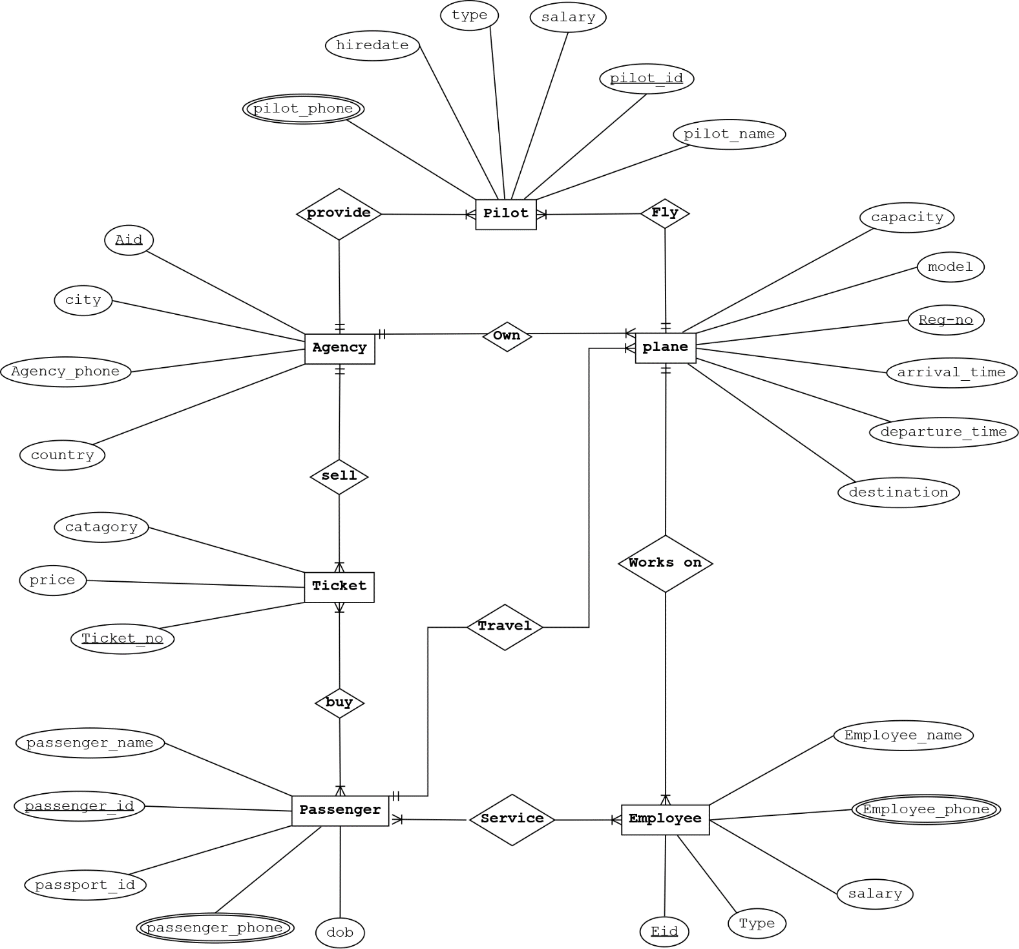

**Normalization:**

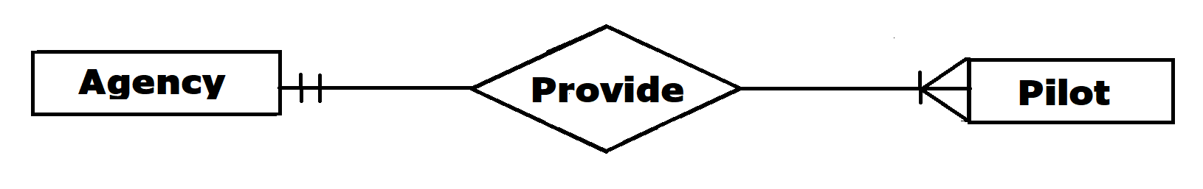

**Provide**(pilot_id,pilot_name,salary,type,pilot_phone,

hiredate,Aid,agency_phone,city,country)

**1NF:** pilot_phone,agency_phone are multivalued attribute.

**2NF:** pilot_id,pilot_name,salary,type,pilot_phone,

hiredate,aid;

Aid,agency_phone,city,country;

**3NF:**pilot_id,pilot_name,salary,type,pilot_phone,

hiredate,aid;

Aid,agency_phone,cc_id;

cc_id,city,country;

**Table:**

pilot_id,pilot_name,salary,type,pilot_phone,hiredate,aid;

aid,agency_phone,cc_id;

cc_id,city,country;

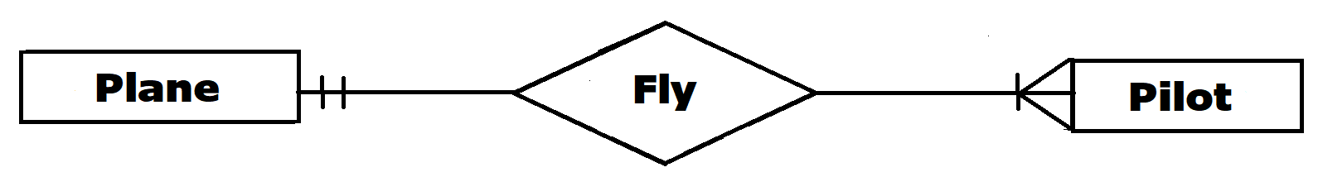

**FLY**(pilot_id,pilot_name,salary,type,pilot_phone,hiredate,reg_no,model,capacity,departure_time,arrival_time,destiation)

**1NF:** pilot_phone is multivalued attribute.

**2NF:**pilot_id,pilot_name,salary,type,pilot_phone,

hiredate,reg_no;

Reg_no,model,capacity,departure_time,arrival_time,

destination;

**3NF:** No transitive dependency.

**Table:**

pilot_id,pilot_name,salary,type,pilot_phone,hiredate,

reg_no;

reg_no,model,capacity,departure_time,arrival_time,

destination;

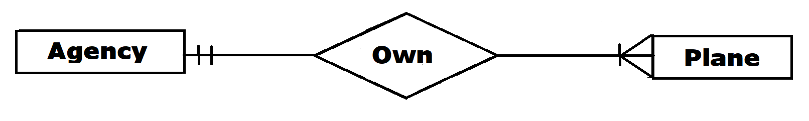

**Own**(aid,agency_phone,city,country,reg_no,model,capacity,departure_time,arrival_time,destination)

**1NF:** No multivalued attributes.

**2NF:** aid,agency_phone,city,country;

reg_no,model,capacity,departure_time,arrival_time,destination,aid;

**3NF:** aid,agency_phone,cc_id;

cc_id,city,country;

reg_no,model,capacity,departure_time,arrival_time,destination,aid;

**Table:**

aid,agency_phone,cc_id;

cc_id,city,country;

reg_no,model,capacity,departure_time,arrival_time,

destination,aid;



**Sell**(aid,agency_phone,city,country,ticket_no,price,

catagory)

**1NF:** No multivalued attributes.

**2NF:** aid, agency_phone,city,country;

Ticket_no,price,category,aid;

**3NF:** aid, agency_phone,cc_id;

Cc_id,city,country;

Ticket_no,price,category,aid;

**Table:**

aid,agency_phone,cc_id;

cc_id,city,country;

ticket_no,price,category,aid;



**Buy**(ticket_no,price,catgory,passenger_id,passport_id,passenger_name,passenger_phone,dob)

**1NF:** phone is multivalued attributes;

**2NF:** ticket_no,price,category;

passenger_id,passport_id,passenger_name,phone,dob;

tp_id,ticket_no,passenger_id;

**3NF:** No transitive dependency.

**Table:**

ticket_no,price,category;

passenger_id,passport_id,passenger_name,phone,dob;

tp_id,ticket_no,passenger_id;

**Works on**(reg_no,model,capacity,arrival_time,

departure_time,destination,eid,employees_name,type,employees_phone,salary)

**1NF:** employees_phone is multivalued attributes.

**2NF:**reg_no,model,capacity,arrival_time,departure_time,destination;

eid,employees_name,type,employees_phone,salary,reg_no;

**3NF:** No transitive dependency.

**Table:** reg_no,model,capacity,arrival_time,departure_time,destination;

eid,employees_name,type,employees_phone,salary,reg_no;



**Travel**(reg_no,model,capacity,arrival_time

,departure_time,destination,passenger_id,passport_id,

passenger_name,passenger_phone,dob)

**1NF:** passenger_phone is multivalued attributes.

**2NF:**reg_no,model,capacity,arrival_time,departure_time,destination;

passenger_id,passport_id,passenger_name,passenger_phone,dob,reg_no;

**3NF:** No transitive dependency.

**Table:** reg_no,model,capacity,arrival_time,departure_time,destination;

passenger_id,passport_id,name,passenger_phone,dob,reg_no;



**Service**(passenger_id,passport_id,passenger_name,passenger_phone,dob, eid,employees_name,type,employees_phone,salary)

**1NF:** passenger_phone,employees_phone are multivalued attributes.

**2NF:**passenger_id,passport_id,passenger_name,

passenger_phone,dob;

eid,employees_name,type,employees_phone,salary;

ep_id,passenger_id,eid;

**3NF:** No transitive dependency.

**Table:** passenger_id,passport_id,passenger_name,passenger_phone,dob;

eid,employees_name,type,employees_phone,salary;

ep_id,eid, passenger_id;

**Total Table:**

**1.**pilot_id,pilot_name,salary,type,pilot_phone,hiredate,

aid;

**2.**aid,agency_phone,cc_id;

**3.**cc_id,city,country;

**4.**pilot_id,pilot_name,salary,type,pilot_phone,hiredate,reg_no;

**5.**reg_no,model,capacity,departure_time,arrival_time,destination;

**6.**aid,agency_phone,cc_id;

**7.**cc_id,city,country;

**8.**reg_no,model,capacity,departure_time,arrival_time,

destination,aid;

**9.**aid,agency_phone,cc_id;

**10.**cc_id,city,country;

**11.**ticket_no,price,category,aid;

**12.**ticket_no,price,category;

**13.**passenger_id,passport_id,passenger_name,phone,

dob;

**14.**tp_id,ticket_no,passenger_id;

**15.**reg_no,model,capacity,arrival_time,departure_time,destination;

**16.**eid,employees_name,type,employees_phone,salary,reg_no;

**17.**reg_no,model,capacity,arrival_time,departure_time,destination;

**18.**passenger_id,passport_id,name,passenger_phone,

dob,reg_no;

**19.**passenger_id,passport_id,passenger_name,

passenger_phone,dob;

**20.**eid,employees_name,type,employees_phone,

salary;

**21.**ep_id,eid,passenger_id;

**Final Table:**

**1.**pilot_id,pilot_name,salary,type,pilot_phone,hiredate,aid;

**2.**aid,agency_phone,cc_id;

**3.**cc_id,city,country;

**4.**pilot_id,pilot_name,salary,type,pilot_phone,hiredate,reg_no;

**5.**reg_no,model,capacity,departure_time,arrival_time,

destination,aid;

**6.**ticket_no,price,category,aid;

**7.**tp_id,ticket_no,passenger_id;

**8.**eid,employees_name,type,employees_phone,salary,

reg_no;

**9.**passenger_id,passport_id,name,passenger_phone,

dob,reg_no;

**10.**ep_id,eid,passenger_id;

**TABLE CREATION:**

**Table creation for table Location:**

create table Location(

cc_id number(10) primary key,

city varchar2(30),

country varchar2(30)

);

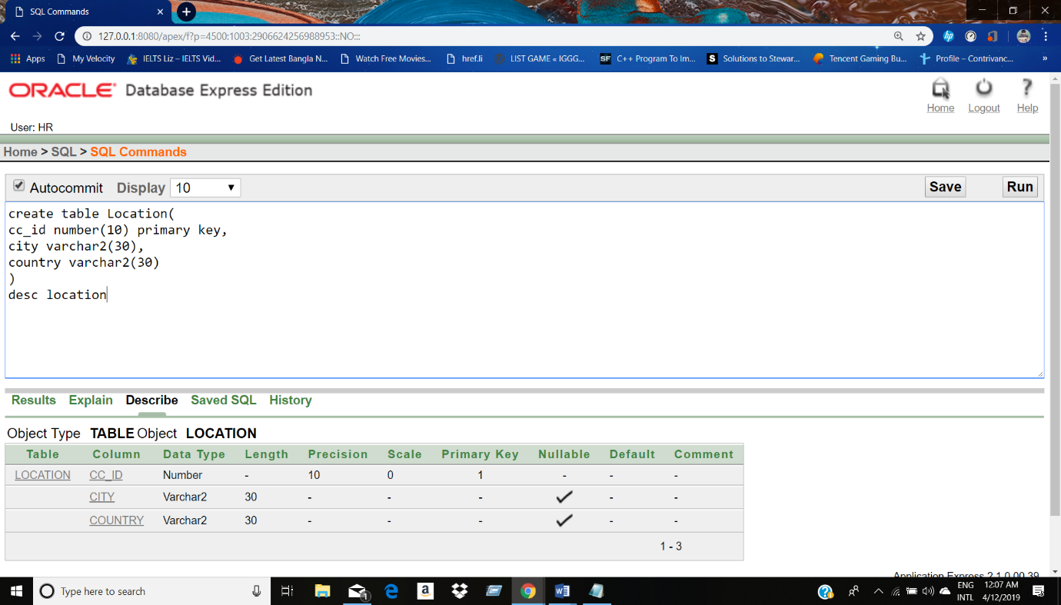

**Sequence creation for table Location:**

Create sequence location_ccid

Increment by 1

Start with 1

Maxvalue 100

**Table creation for table Agency:**

create table AGENCY

(

aid number(10)primary key,

agency_phone number(20) unique,

cc_id number(10),

foreign key(cc_id) references Location(cc_id)

);

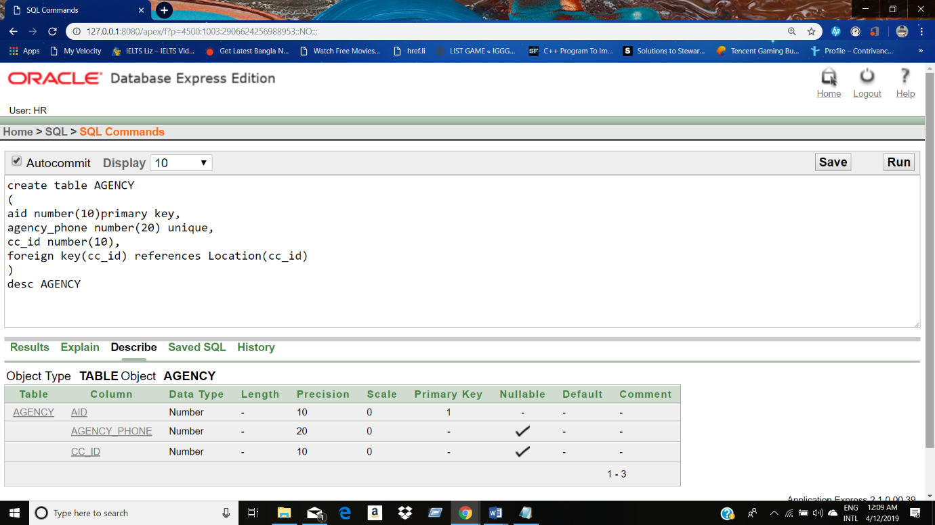

**Sequence creation for table Agency:**

Create sequence agency_aid

Start with 1101

Increment by 1

Maxvalue 2000;

**Table creation for table Plane:**

create table plan(

plane_reg_no number(25) primary key,

model varchar2(15),

capacity number(8),

arrival_time varchar2(10),

departure_time varchar2(10),

destination varchar2(25),

aid number(10),

foreign key(aid) references AGENCY(aid)

);

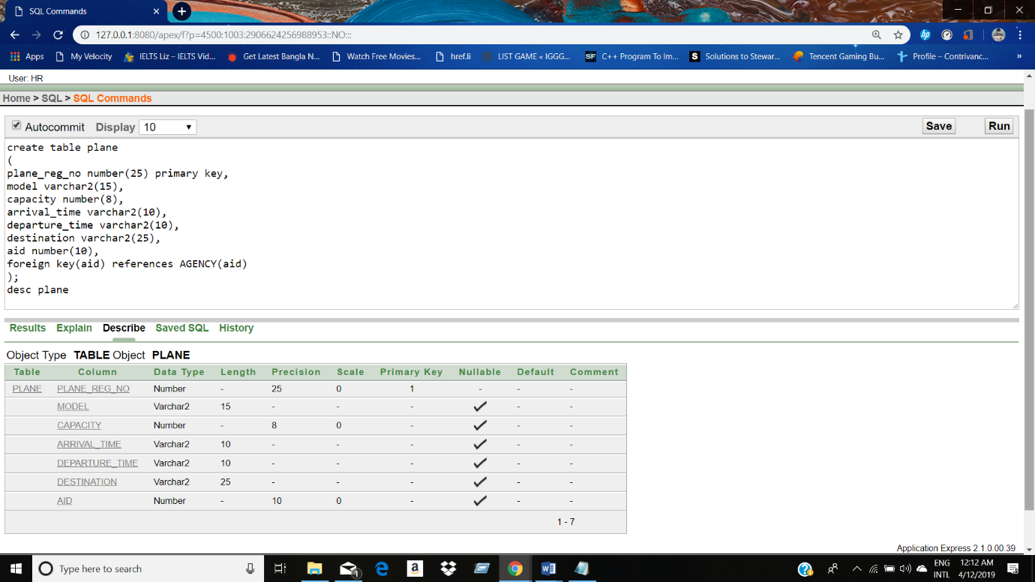

**Sequence creation for table Plane:**

Create sequence plane_regno

Start with 2

Increment by 1

Maxvalue 3000

**Table creation for table Pilot:**

create table Pilot

(

pilot_id number(10),

pilot_name varchar2(10),

salary number(5),

type varchar2(50),

pilot_phone number(20),

hiredate date,

plane_reg_no number(25),

foreign key (plane_reg_no) references plane(plane_reg_no));

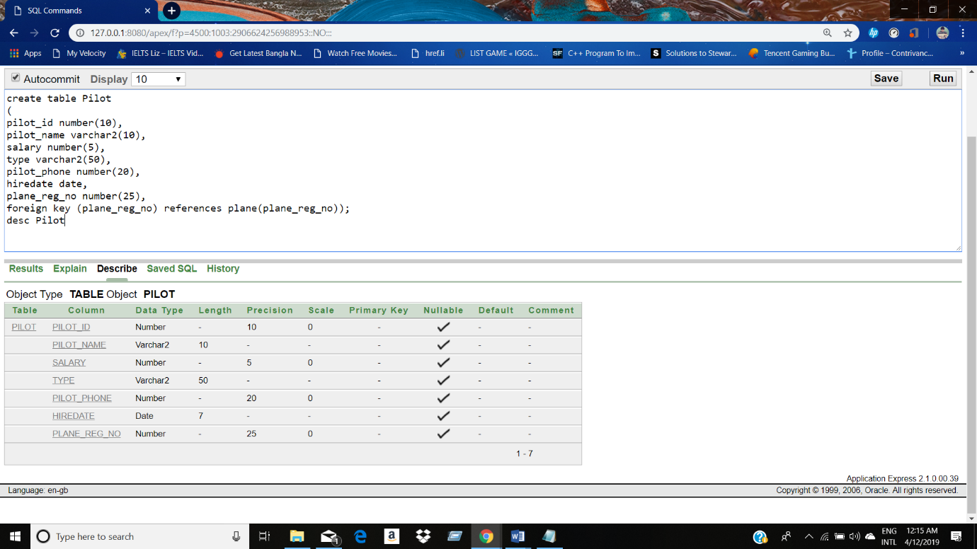

**Table creation for table Passenger:**

create table passenger

(

passenger_id number(10),

passport_id varchar2(10),

passenger_name varchar2(20),

passenger_phone number(25),

dob date,

plane_reg_no number(25),

foreign key (plane_reg_no) references plane(plane_reg_no)

);

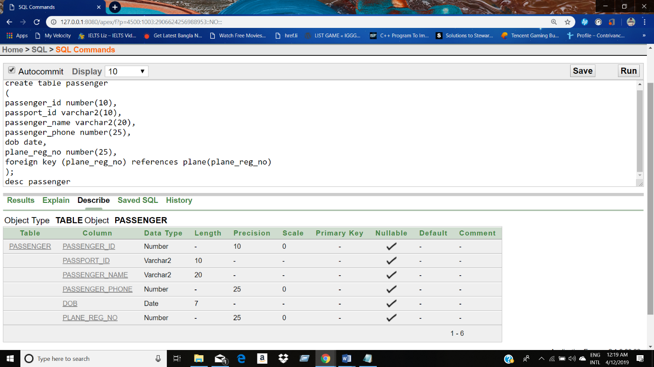

**DATA INSERTION:**

**Data insertion into table Location:**

insert into Location values(location_ccid.nextval,'NEWYORK','AMERICA');

insert into Location values(location_ccid.nextval,'BERLIN','GERMANY');

insert into Location values(location_ccid.nextval,'TORONTO','CANADA');

insert into Location values(location_ccid.nextval,'CHITTAGONG','BANGLADESH');

insert into Location values(location_ccid.nextval,'KOLKATA','INDIA');

select * from location

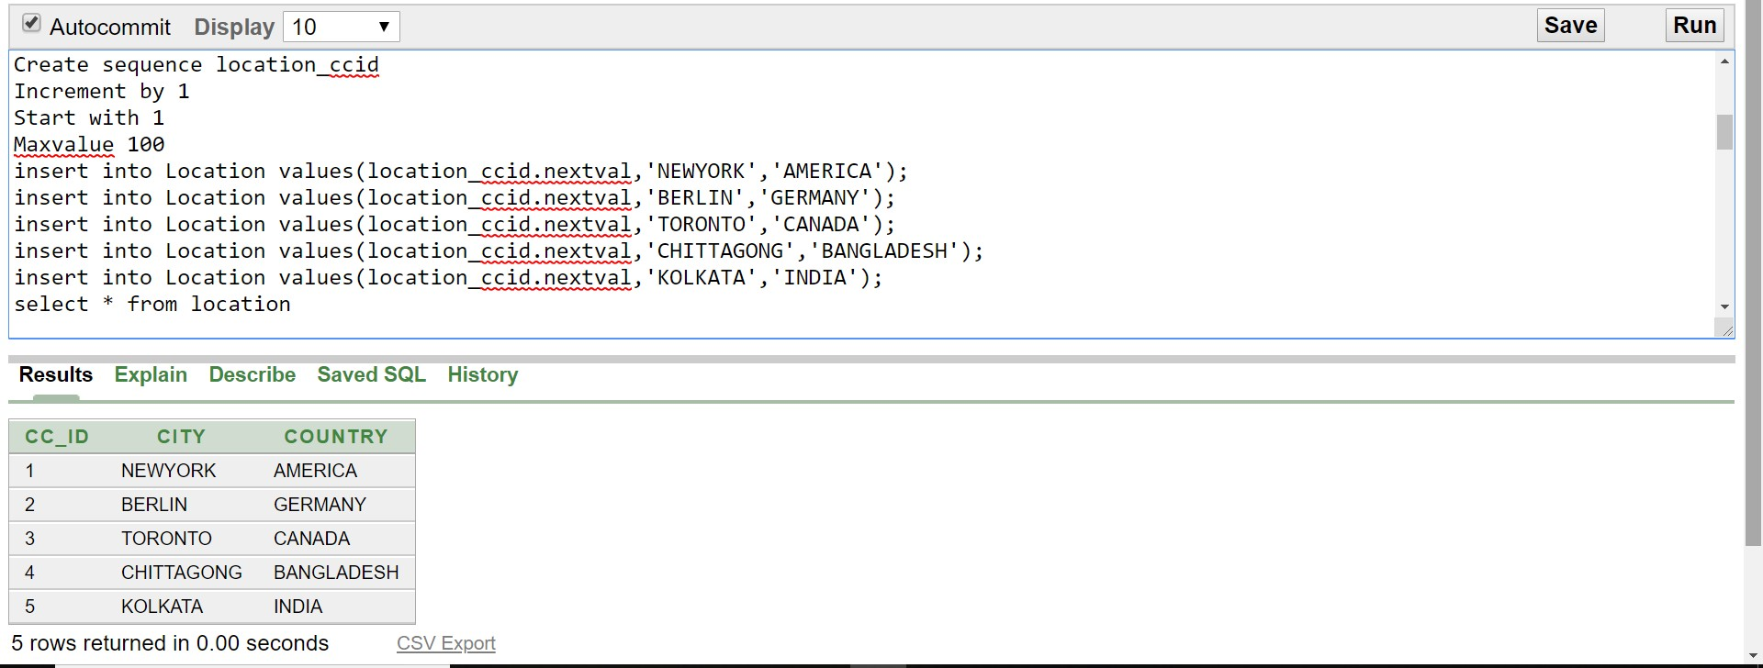

**Data insertion into table Agency:**

insert into agency values(agency_aid.nextval,'123',1);

insert into agency values(agency_aid.nextval,'234',2);

insert into agency values(agency_aid.nextval,'345',3);

insert into agency values(agency_aid.nextval,'456',4);

insert into agency values(agency_aid.nextval,'567',5);

select* from AGENCY

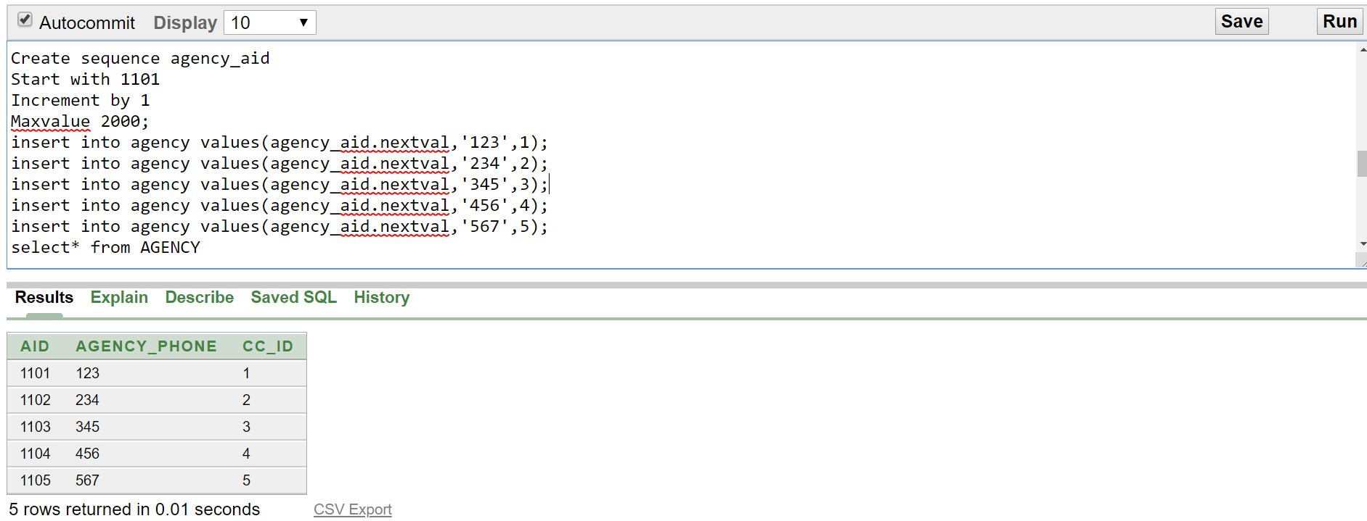

**Data insertion into table Plane:**

insert into plane values(plane_regno.nextval,'Boeing 777-200',800,'10AM','10PM','NEWYORK','1101');

insert into plane values(plane_regno.nextval,'Airbus A340-600','600','12AM','09PM','CHITTAGONG','1104');

insert into plane values(plane_regno.nextval,'Boeing 777-300','900','08AM','05PM','KOLKATA','1103');

insert into plane values(plane_regno.nextval,'Boeing 747-8','747','11AM','07PM','TORONTO','1102');

insert into plane values(plane_regno.nextval,'Airbus A380-800','853','09AM','09PM','BERLIN','1105');

select * from plane

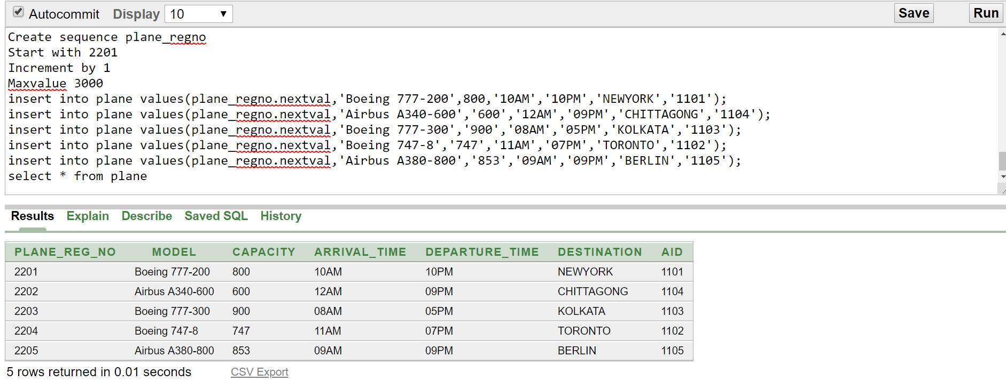

**Data insertion into table Pilot:**

insert into pilot values('3301','DIGANTA','20000','COMMERCIAL PILOT','0180001','25-OCT-97','2201')

insert into pilot values('3302','MAISHA','22000','COMMERCIAL PILOT','0160004','24-DEC-99','2202')

insert into pilot values('3303','SADDI','19000','AIRLINE TRANSPORT PILOT','0170009','14-MAR-98','2203')

insert into pilot values('3304','NAFIS','15000','SPORT PILOT','0140003','02-JUN-02','2204')

insert into pilot values('3305','KIRAN','18000','RECREATIONAL PILOT','0170001','27-FEB-94','2205')

select * from pilot

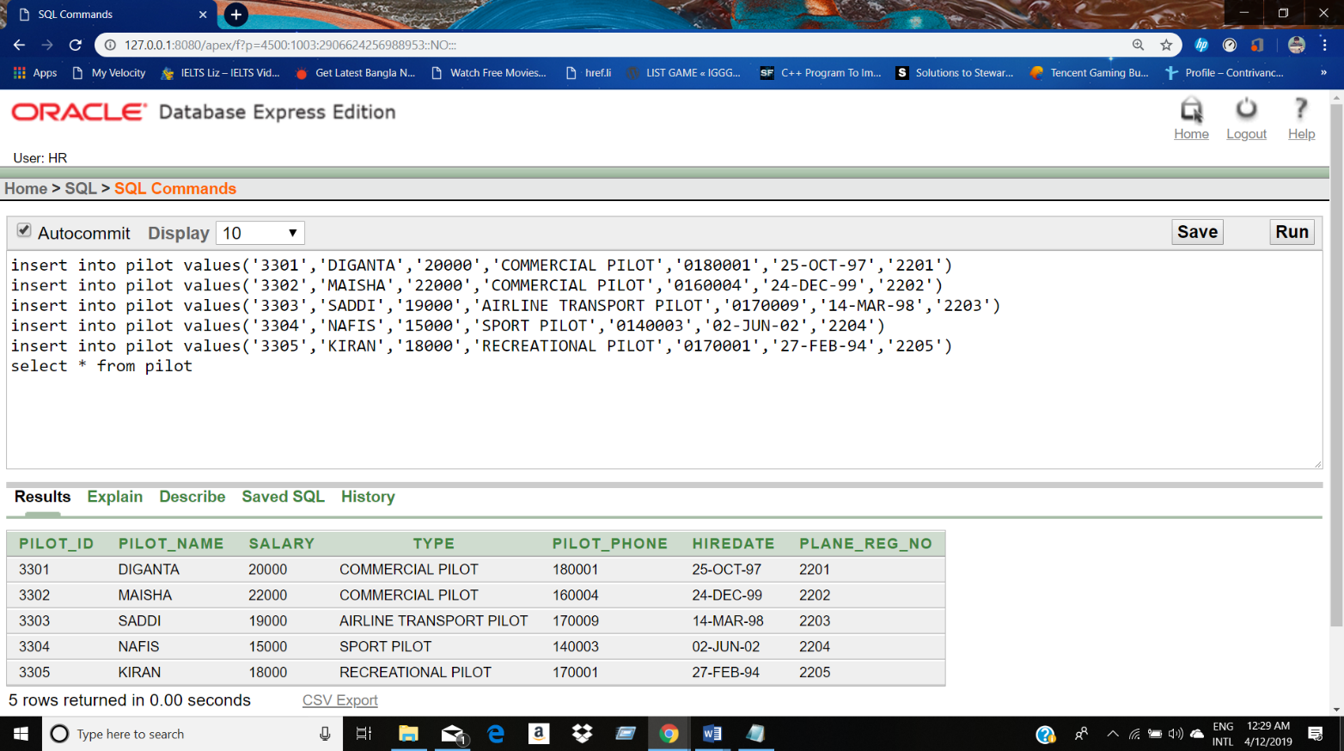

**Data insertion into table Passenger:**

insert into passenger values('4401','PASS345','IQBAL','750043','14-FEB-83','2202')

insert into passenger values('4402','PASS678','TAREQ','101332','01-DEC-74','2205')

insert into passenger values('4403','PASS901','ZEBA','289525','08-MAR-87','2201')

insert into passenger values('4404','PASS234','ANIRBAN','548543','09-JUL-92','2201')

insert into passenger values('4405','PASS563','NILHAN','973353','23-NOV-97','2204')

SELECT * from passenger

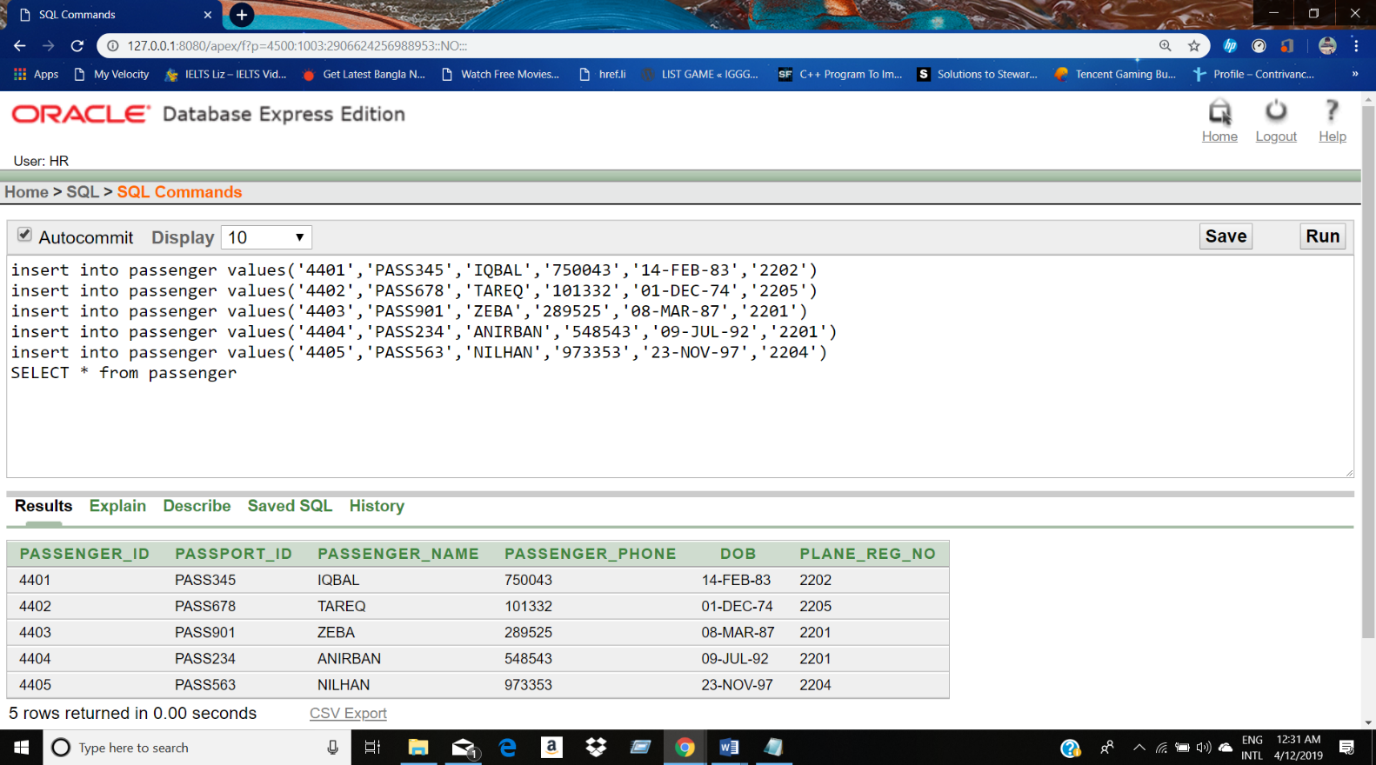

**QUERY:**

**General:**

1.Display those passengers who contain a letter a to their name.

2.Display the name of the passengers whose passport number is PASS234 .

**Group function:**

1.Write a sql statement to find the average salary of all pilots.

2.Write a sql statements to find the most senior pilot of all pilots.

**Sub query:**

1.Display the name and hire date of all pilots who was hired after pilot number 3301.

2.Display the name , salary for all pilots who earn more than the average salary.

**Joining:**

1.Write a query in SQL to display the passengers name, passport number plane registration number and plane model for all passengers of passenger number 4403.

2.Write a query in SQL to display pilot name, salary, destination for all pilots whose salary is grater than 1700.

**View:**

1.Create a view named PASS20 that contains the passenger number , passenger name and destination for all passengers where passenger number less than 4403.Label the column PASSENGER_ID,PASSENGER and DESTINATION.

2. Create a view named PLT20 that contains the pilot number ,pilot name and salary for all pilots where pilot number grater than 3302.Label the column PILOT_ID,PILOT and SALARY.

**Conclusion:**

After completing the project the basic concept of database management system is known to the group members. There are still many flaws which can be improved by the group members according to the demand of time.